**Three phase 6 step 180 & 120 mode bridge inverters**

**A. Utility Factor, output current, switch current and output power**

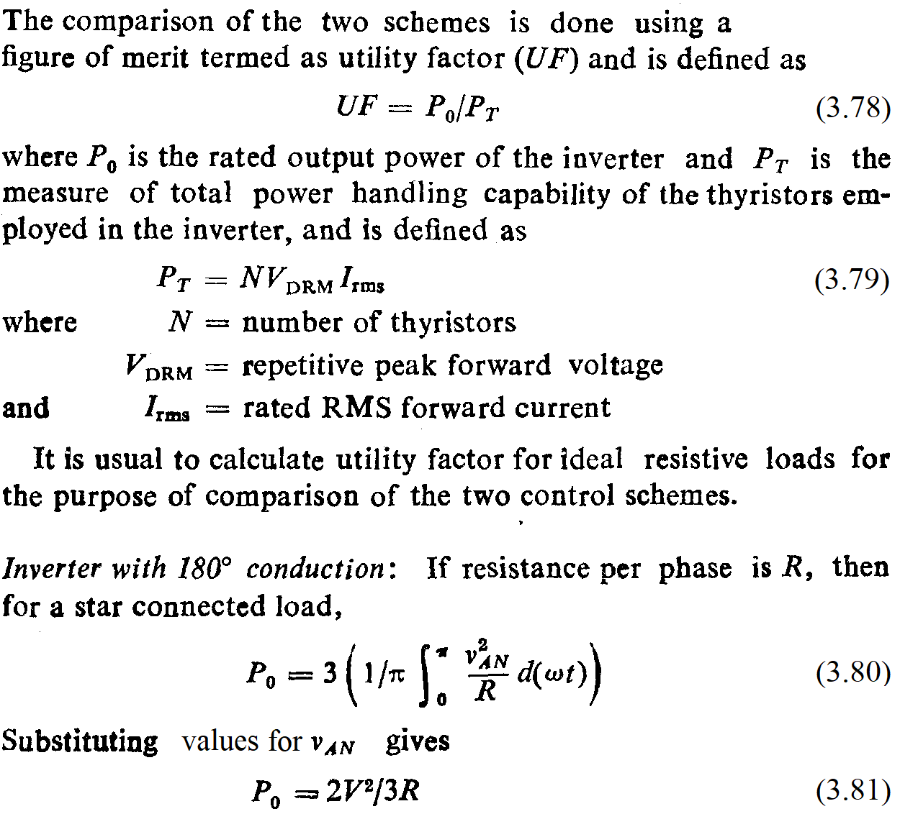

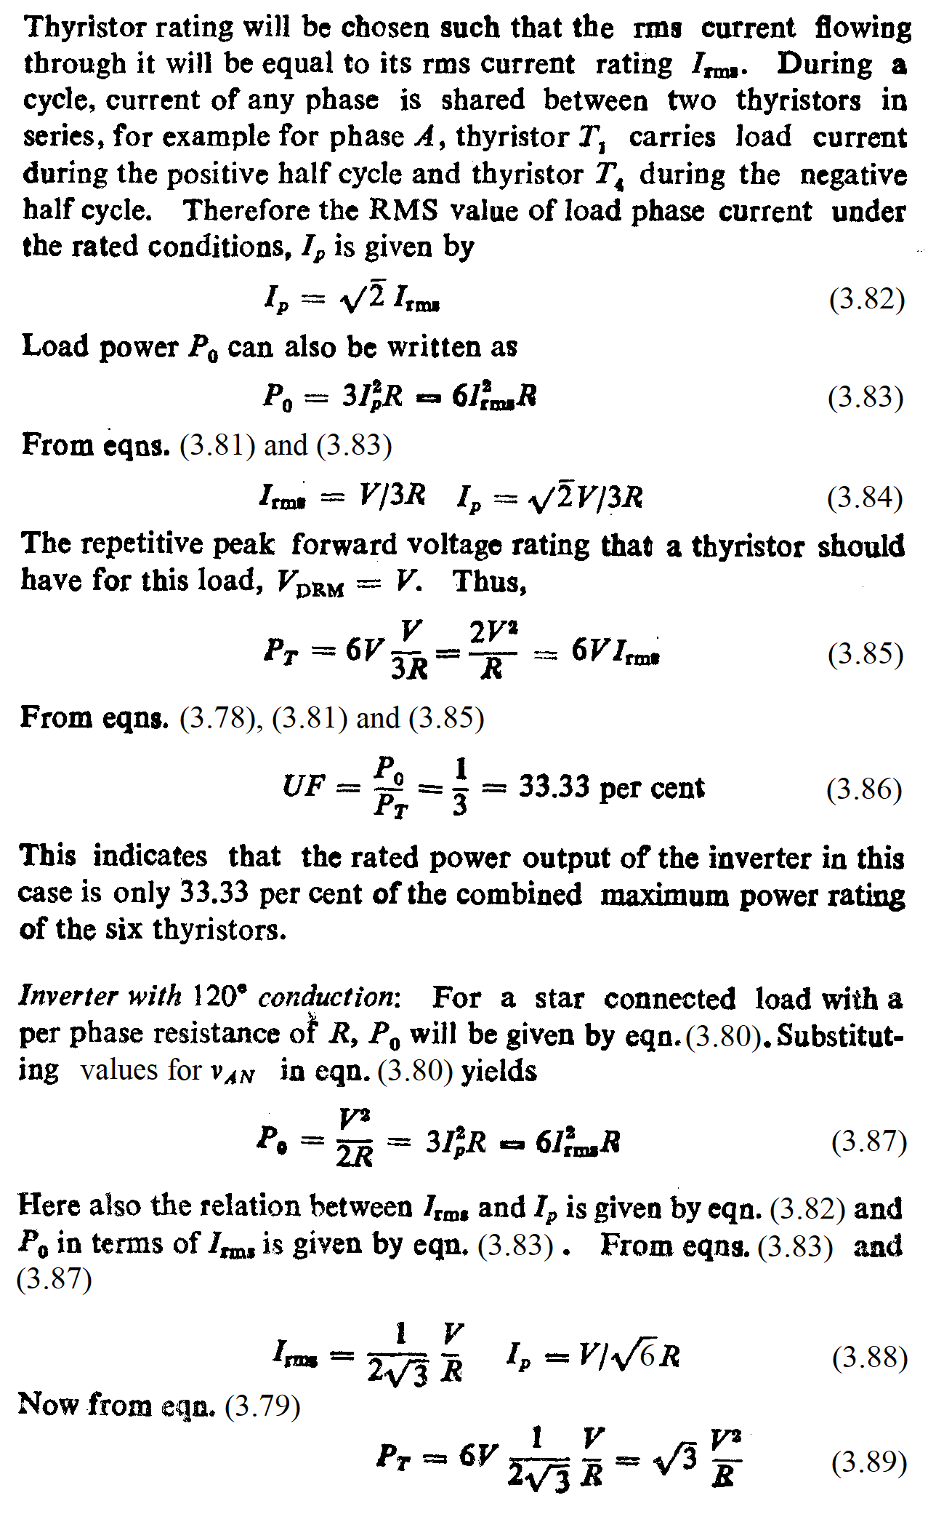

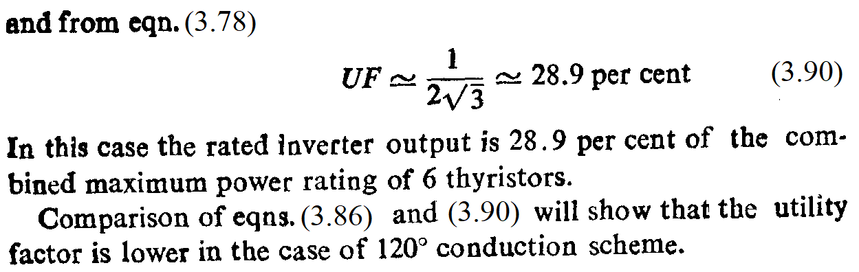

**B. Summary of expressions for 180º and 120º modes**

|  |  |  |  |
| --- | --- | --- | --- |
| **Sr. No.** | **Parameter** | **180º** | **120º** |
| 1 | Line-to-line waveform | Quasi-square, amplitude Vs, pulse width 120º | 6 step, step amplitudes Vs/3, 2Vs/3 |
| 2 | Line-to-neutral waveform | 6 step, step amplitudes Vs/2, Vs | Quasi-square, amplitude Vs/2, pulse width 120º |
| 3 | VL rms | $\sqrt{\frac{2}{3}}$ Vs | Vs |
| 4 | VL1 rms | $\frac{\sqrt{6}}{π}$ Vs | Vs |
| 5 | VP rms | $\frac{\sqrt{2}}{3}$ Vs | Vs |
| 6 | VP1 rms | $\frac{\sqrt{2}}{π}$ Vs | Vs |
| **Sr. No.** | **Parameter** | **180º** | **120º** |
| 7 | IP rms = IL rms (for balanced star R load) | VP /R | VP /R |
| 8 | IP1 rms = IL1 rms (for balanced star R load) | VP1 /R | VP1 /R |
| 9 | ISW rms | VP /R) | VP /R) |
| 10 | Po average | $\frac{2V_{s}^{2}}{3R}$ | $$\frac{\sqrt{3}V_{s}^{2}}{R}$$ |